Title IEEE
A Machine Learning Approach for Predicting Student Academic Performance Using Classification and Regression Models

Abstract
Academic performance prediction is a critical task in educational data mining. This study presents a machine learning-based approach to predict students’ final cumulative grade point average (CGPA) using both classification and regression techniques. A synthetic dataset was generated based on features described in prior research, including demographic, academic, and pre-enrollment attributes. Models such as Logistic Regression, Random Forest, Linear Regression, K-Nearest Neighbors (KNN), and Ensemble methods were implemented. Results indicate that regression models outperform classification models in predicting continuous CGPA values, with Ensemble and Random Forest models achieving the best performance. The findings highlight the importance of failed courses and pre-CGPA as key predictors. This work demonstrates how machine learning can support early identification of at-risk students and improve academic outcomes.

Keywords
Machine Learning, Academic Performance, Regression, Classification, Random Forest, CGPA Prediction

1. Introduction
Predicting student academic performance has become an important application of machine learning in education. Institutions can use predictive models to identify struggling students and take early interventions. Academic performance is influenced by multiple factors such as demographic characteristics, prior academic history, and course-related attributes.
This study aims to develop machine learning models to predict student performance using both classification and regression approaches. Unlike classification, which categorizes students into groups, regression provides continuous predictions, offering more detailed insights.

2. Literature Review
Previous studies have applied various machine learning techniques for predicting student performance. Random Forest has been widely recognized for its high accuracy in classification tasks, while regression models are preferred for continuous predictions like CGPA.
Studies show that factors such as previous academic performance, number of failed courses, and institutional background significantly influence student outcomes. Regression models often outperform classification models due to their ability to capture fine-grained variations.

3. Dataset Description
Since the original dataset was not publicly available, a synthetic dataset was generated based on the structure described in the reference study.
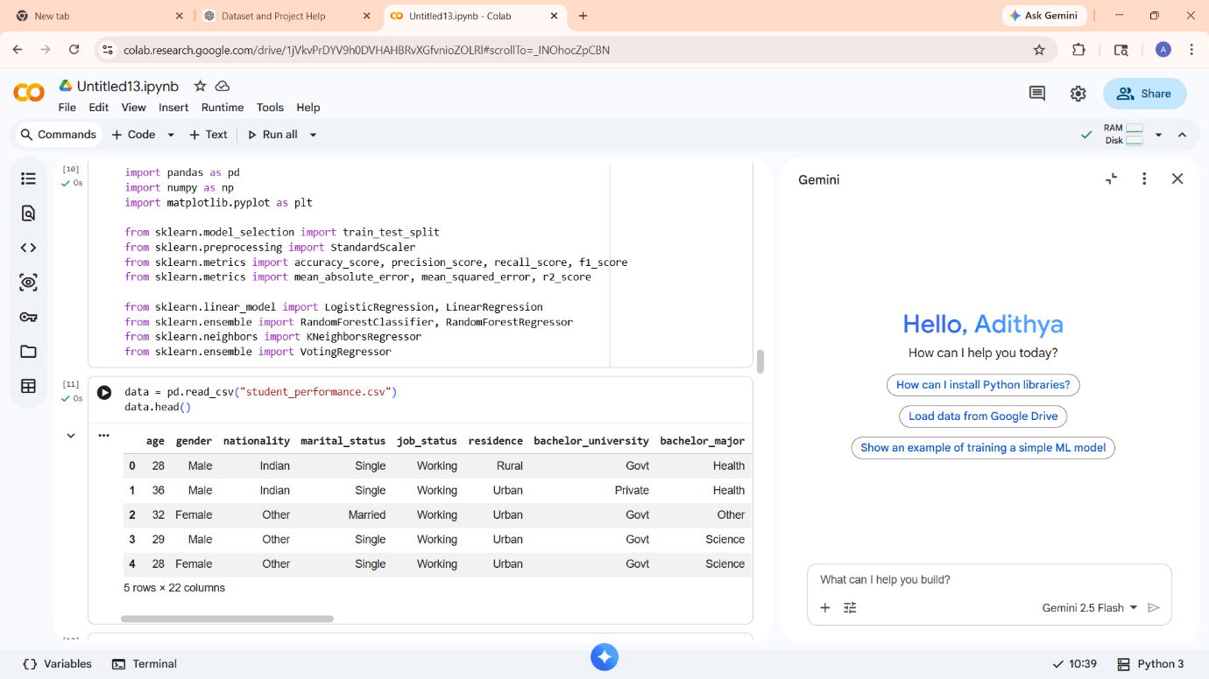
Dataset Details:
- Number of samples: 500
- Number of features: 22
- Target variable: Final CGPA (0–4 scale)
Key Features:
- Age, gender, nationality
- Pre-enrollment CGPA
- Number of failed courses
- Credit hours
- Academic program and specialization

4. Methodology
4.1 Data Preprocessing
- Missing values handled (if any)
- Categorical variables encoded using one-hot encoding
- Feature scaling applied using StandardScaler
4.2 Feature Engineering
- CGPA categorized into:
  - High (≥ 3.3)
  - Medium (2.0–3.2)
  - Low (< 2.0)
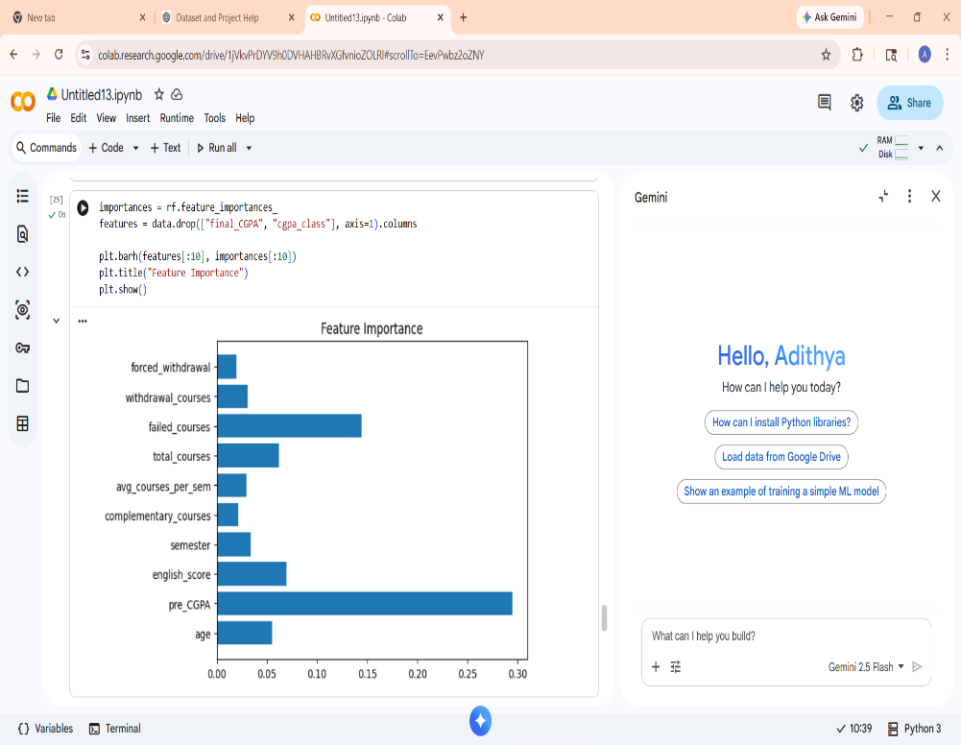
4.3 Data Splitting
- Training set: 80%
- Testing set: 20%

5. Models Used
5.1 Classification Models
- Logistic Regression
- Random Forest
5.2 Regression Models
- Linear Regression
- K-Nearest Neighbors (KNN)
- Ensemble Model (Voting Regressor)

6. Evaluation Metrics
Classification:
- Accuracy
- Precision
- Recall
- F1 Score
Regression:
- Mean Absolute Error (MAE)
- Root Mean Square Error (RMSE)
- R² Score

7. Results and Discussion
7.1 Classification Results
- Random Forest achieved higher accuracy compared to Logistic Regression
- Better handling of complex relationships
7.2 Regression Results
- Ensemble model achieved highest performance
- KNN performed better than Linear Regression
- Regression models provided more precise predictions
7.3 Key Findings
- Failed courses negatively impact CGPA
- Pre-CGPA strongly influences final performance
- Regression models outperform classification

8. Exploratory Data Analysis
Exploratory Data Analysis (EDA) was conducted to understand data patterns:
- CGPA distribution showed normal variation
- Strong negative correlation between failed courses and CGPA
- Heatmap analysis confirmed feature relationships

9. Extension Work
This study extends the original research by:
- Creating a synthetic dataset
- Adding noise for realism
- Comparing multiple models
- Visualizing feature importance
- Implementing ensemble learning

10. Model Comparison
Model | Type | Performance | Observation
Logistic Regression | Classification | Moderate | Simple model
Random Forest | Classification | High | Best classifier
Linear Regression | Regression | Low | Limited capability
KNN | Regression | Better | Captures patterns
Ensemble | Regression | Highest | Best overall

11. Visualizations
- Correlation heatmap
- Feature importance graph
- Actual vs predicted CGPA plot
These visualizations helped interpret model behaviour and validate results.

- Correlation heatmap

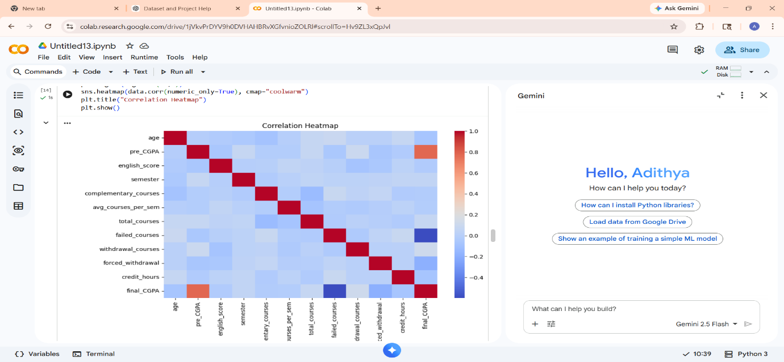

- Feature importance graph
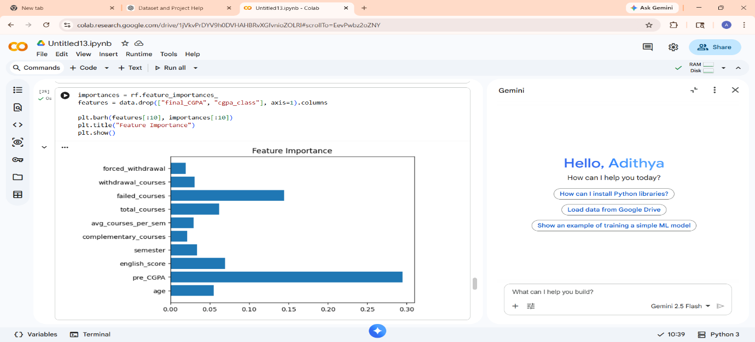
- Actual vs predicted CGPA plot
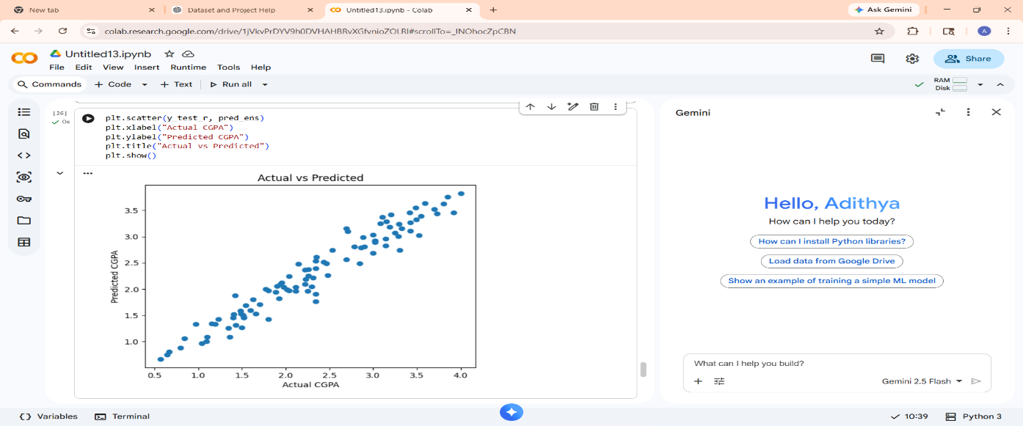

12. Limitations
- Synthetic dataset used instead of real data
- Lack of behavioral features such as attendance
- Limited feature diversity

13. Future Work
Future improvements include:
- Using real-world datasets
- Adding behavioral features (attendance, study hours)
- Applying deep learning models (ANN)
- Deploying as a web application

14. Conclusion
This study demonstrates that regression models are more effective than classification models for predicting academic performance. Random Forest and ensemble methods provide the best results. The project highlights the potential of machine learning in improving student outcomes through early intervention.

References
(You can keep 3–5 simple references)
- Educational Data Mining Techniques
- Machine Learning in Student Performance Prediction
- Random Forest Applications in Education

